***This document contains project 1 with 10 tasks and their testing results and observations. ***

Author – Snehal P. Dhamdar

Reviewed by – Kumar Gaurav Sir

**Project - 1**

**Resilient Web Server which can auto heal and expand itself**

**Index**

|  |  |
| --- | --- |
| **Sr No** | **Tasks** |
| 1 | S3 Bucket  Index.html |
| 2 | Ec2 role |
| 3 | Vpc |
| 4 | Uds |
| 5 | Templates |
| 6 | Asg |
| 7 | Asg |
| 8 | Route 53 |
| 9 | Final testing results |

**Task 1-**

S3 Bucket Index.html

1)Create S3 bucket

2)Public Access…. Bucket Policy

3)**Create an SNS topic** …carefully give

privileges to SNS topic so that any new

object uploaded you should be notified

4)Upload Index.html

Content

**My auto web page is coming from**

And confirm if got notified any SNS

5)Rename Make sure spelling is index.html

Only

**Create s3 bucket-**

**Steps to create bucket**

AWS console >> s3>> create bucket >> give unique bucket name >> select region in which bucket need to create >> enable ACL as we need to public bucket >> uncheck block public access and acknowledge the box notifications>>enable bucket versioning if required >> create bucket

Please refer the below snapshots –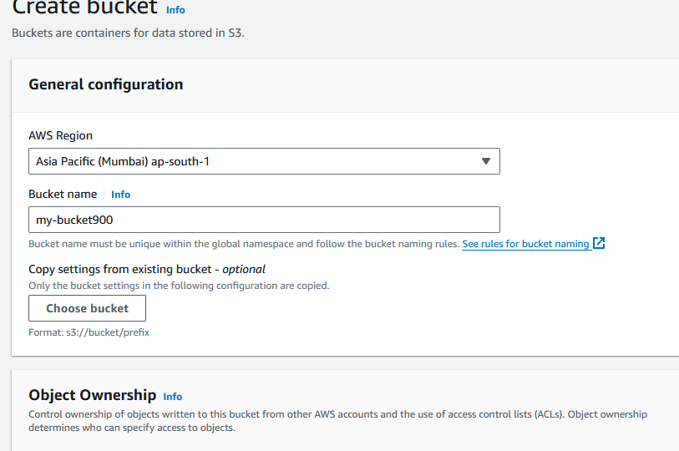

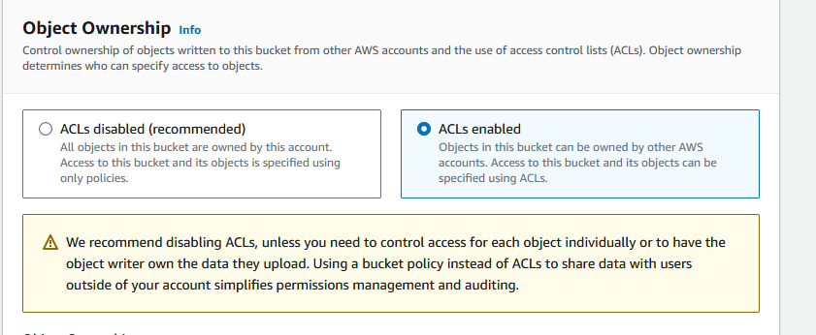

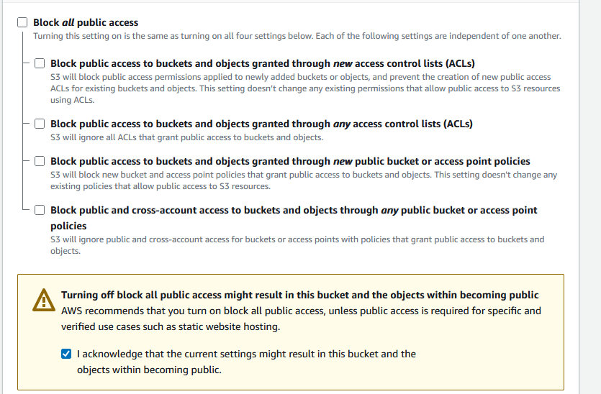

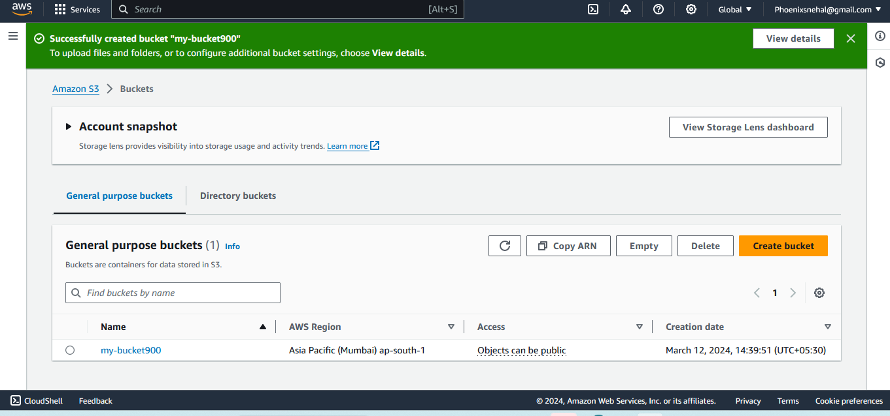

You will receive a message that “Successfully created bucket "my-bucket900"

To upload files and folders, or to configure additional bucket settings, choose View details.

” as shown in snapshots

**Public access –**We need to follow these 2 points to enable public access for bucket and their object so that we can access it from web

Steps to enable public access

## Bucket Public –

## Click in particular bucket in s3 >> permissions >> Block public access (bucket settings) off >> bucket policy >> object ownership (ACL enabled ) .

## If you public bucket it doesn’t mean all the objects in bucket is public you have to enable object public option also which is “make public using ACL”

## Object Public –

## Select particular object >> action >> make public using acl

## 

## In the same bucket we have 2 objects but only one object is public

## Testing -

## Public - <https://my-bucket900.s3.ap-south-1.amazonaws.com/ram.txt>

## Observation – If you public bucket it doesn’t mean all the objects in bucket is public you have to enable object public option also

4)Upload Index.html

Content **My auto web page is coming from**

**Created index.html page using visual studio**

Steps –open visual studio

1. Create new file
2. Type html “create html build in”
3. Push code to create html and edit as shown in snapshot

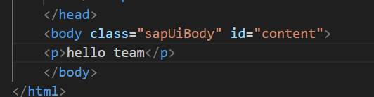

Uploading this file in bucket

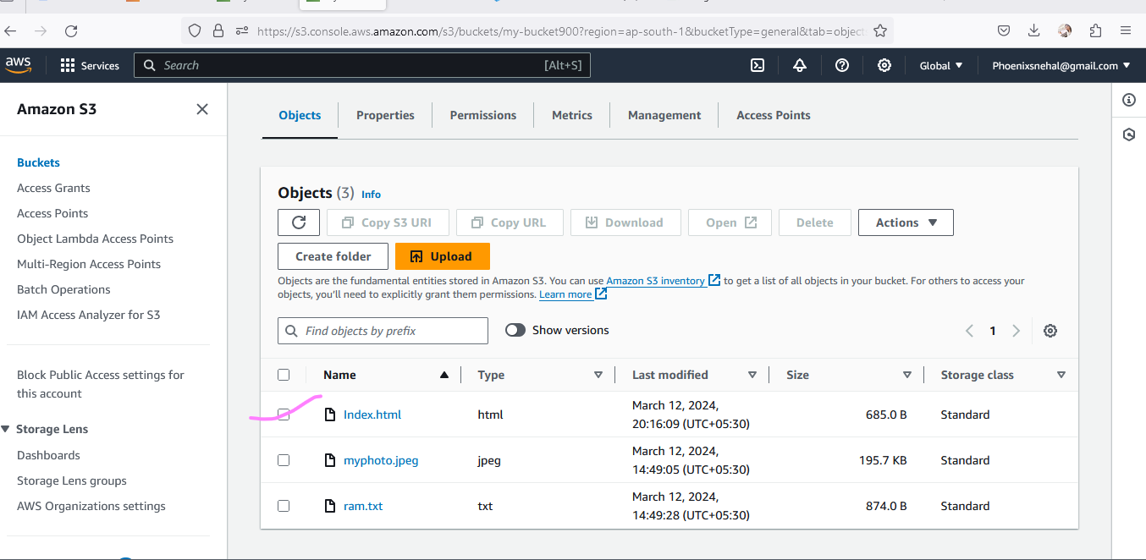

we can now access Index.html file

received sns notification –

1. Create topic. Select everyone in access policy
2. Create subscription.
3. Subscribe topic.
4. S3 >> bucket >> properties >> event notification >> create event

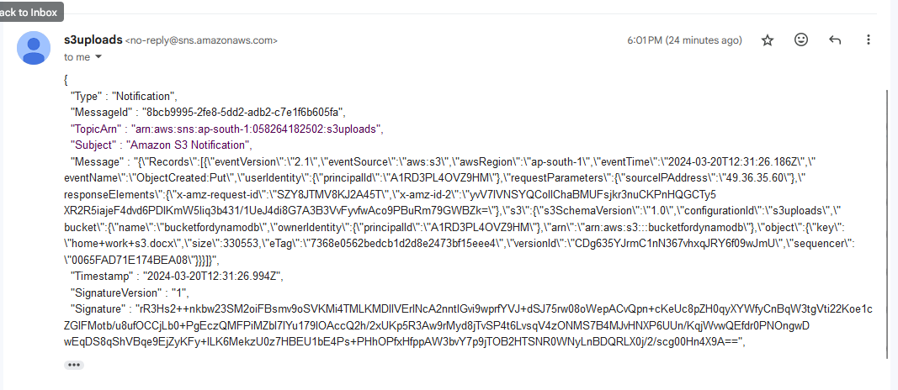

5)Rename Make sure spelling is index.html

Only

Select object >> action >> rename object

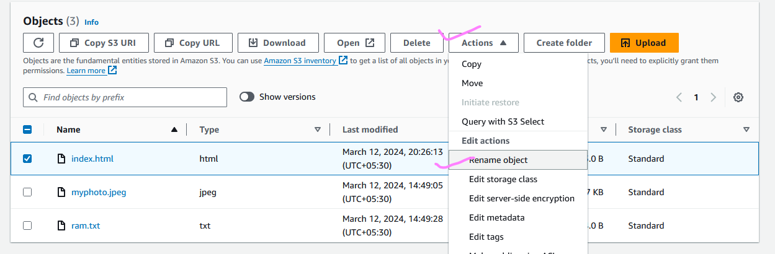

**Task 2**

1. **Create ec2 role -**

Created ec2 role with s3 and cloud watch full access kindly follow the below steps with snap shots –

In aws console go to-

IAM >> create new role >> aws service>> use case select ec2 >> next>> attach s3fullaccess and cloud watch full access. >> ec2role (name of role)>> create role.

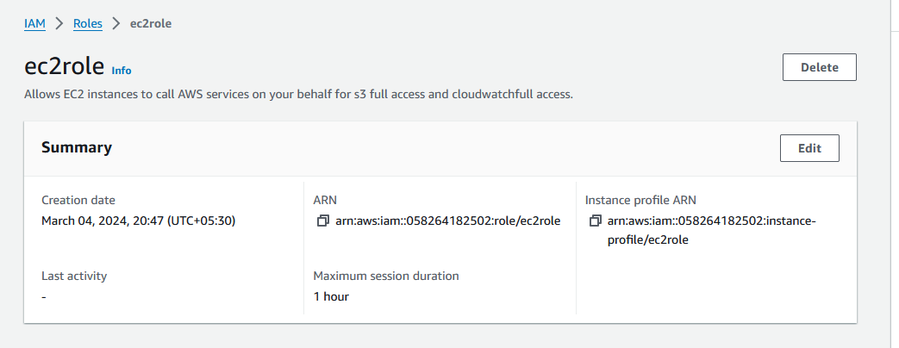

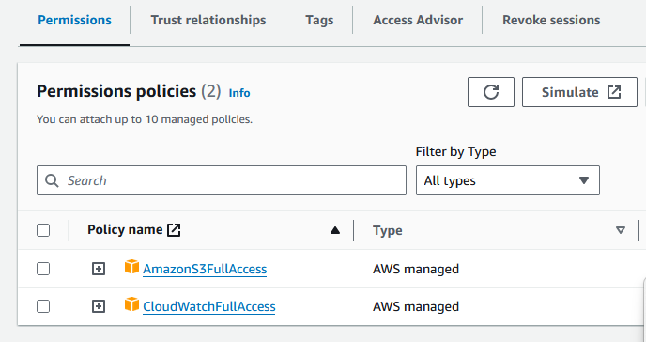

**Observation –**

If we attach this role to any instance that instance will able to read and write s3 bucket and access cloud watch services.

We need to attach policy to ec2role, policy manages permission, whether it is a user, group of user or role all of them requires one or more policy to get some permissions. Role is needed when we need to interact two different services in aws. Role is basically a trust build-up between two services. Policy is a JSON script which work on key value pair.

**Task 3**

**1 Create Vpc 10.0.0.0/16…MyVpc**

Go to console >> VPC >> create vpc >>only vpc >> give name of “myvpc ” >> mention CTDR range 10.0.0.0/16 >> create vpc

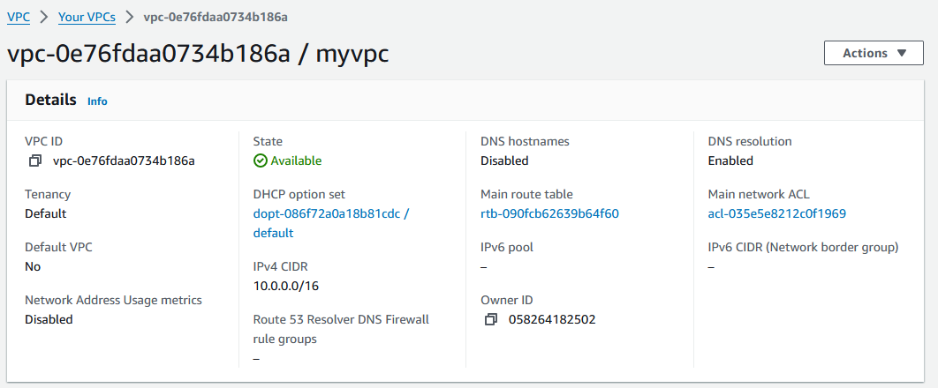

**2)Create IGW….and Attach to VPC**

VPC >> Internet gateway >>create >> give name >> attach to myvpc

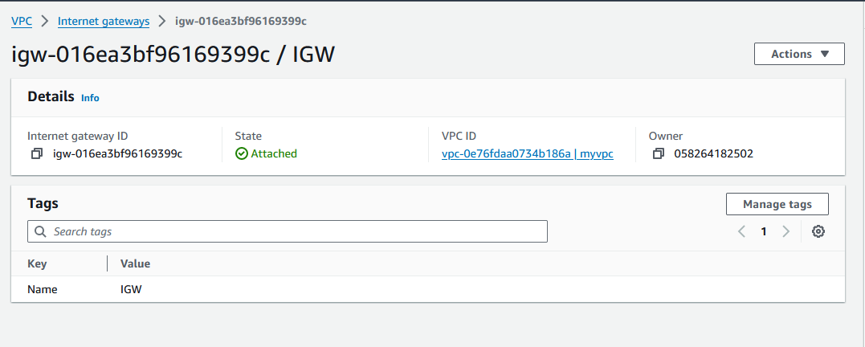

**3)Create 3 Public Subnet**

**MyPub1….10.0.1.0/24….us-east-1a**

**MyPub2….10.0.2.0/24….us-east-1b**

**MyPub3….10.0.3.0/24…us-east-1c**

**All above subnets with Auto assign**

**Public IP**

Vpc >> subnet >> create subnet >> name of subnet >> attach vpc >> create

Select subnet >> action >> edit subnet setting >> enable puclic ip

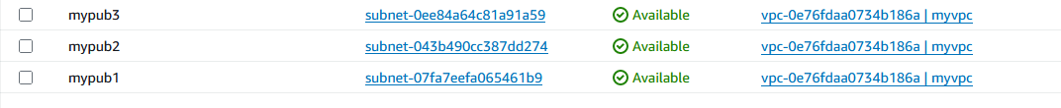

**4)Create Route table point to IGW and**

**proper subnet association**

**MyPubRt**

**0.0.0.0/0…….Igw**

VPC >> route table >> create new rt>>name of rt(MypubRt)>>select myvpc>>create route table

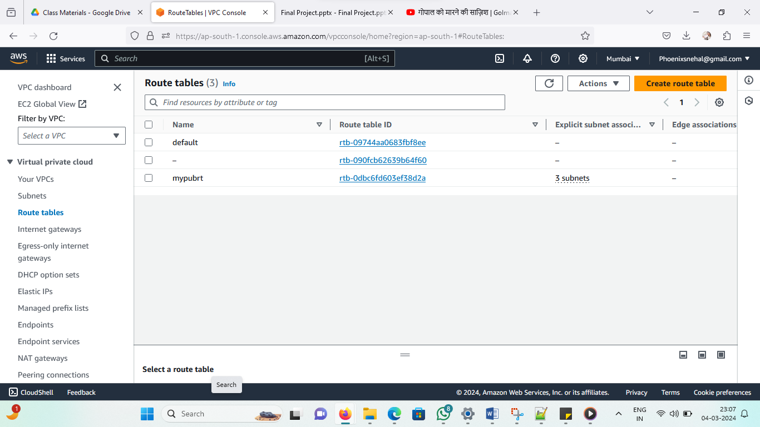

**Now attach mypubrt to all 3 subnets –**

Route table open >> subnet association >> edit subnet association >> select all subnets >> save setting

Now we are getting the resource map as below 3 subnet created and attached to igw

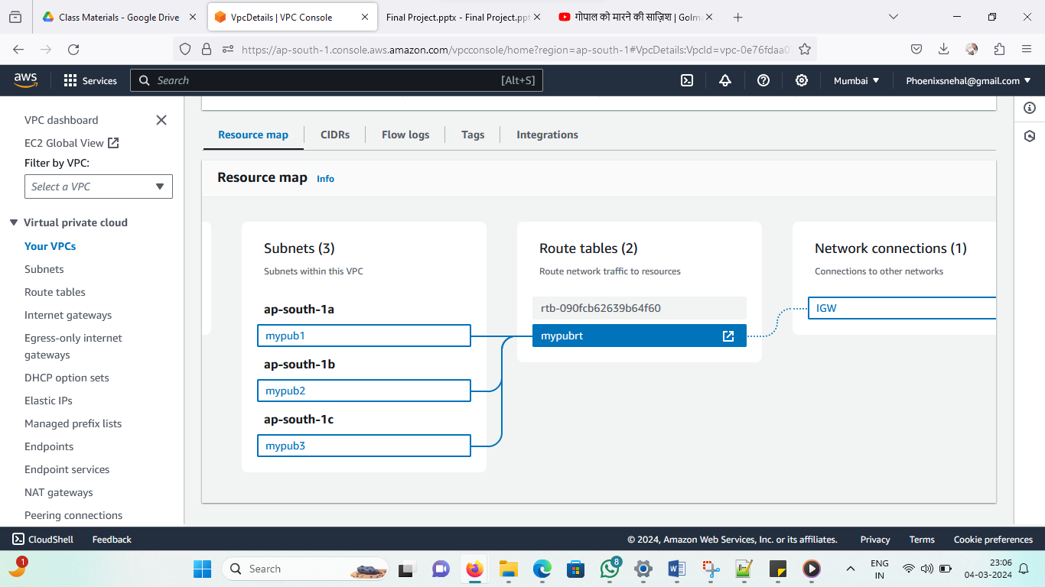

**5)Create Security group**

**MySg_web_ssh**

**22……0.0.0.0/0……..allow**

**80……0.0.0.0/0………allow**

Vpc >> security group>> name of sg (MySg_web_ssh)>> select http and ssh port >> anywhere >> create

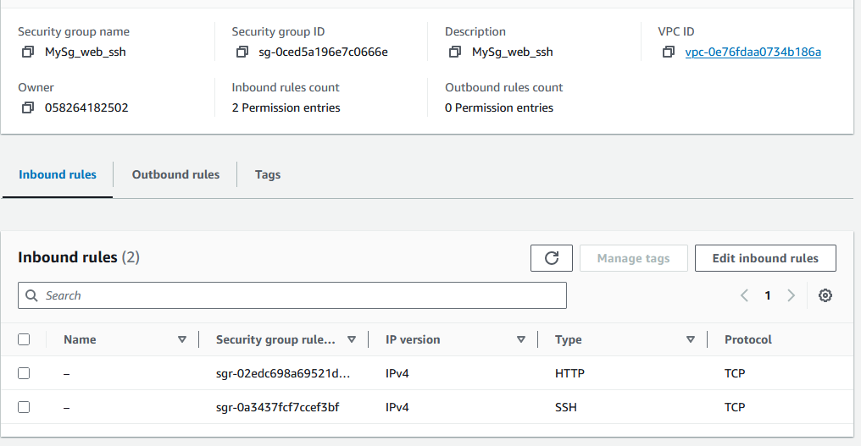

**Task 4**

**User data script –**

**#!/bin/bash**

**yum install -y httpd**

**sleep 5**

**aws sync s3://yr_bucket /var/www/html/ --region us-east-1**

**sleep 5**

**echo $(hostname) >>/var/www/html/index.html**

**service httpd restart**

**created ec2 instance using above script – ec2 >> advance option >> User data script**

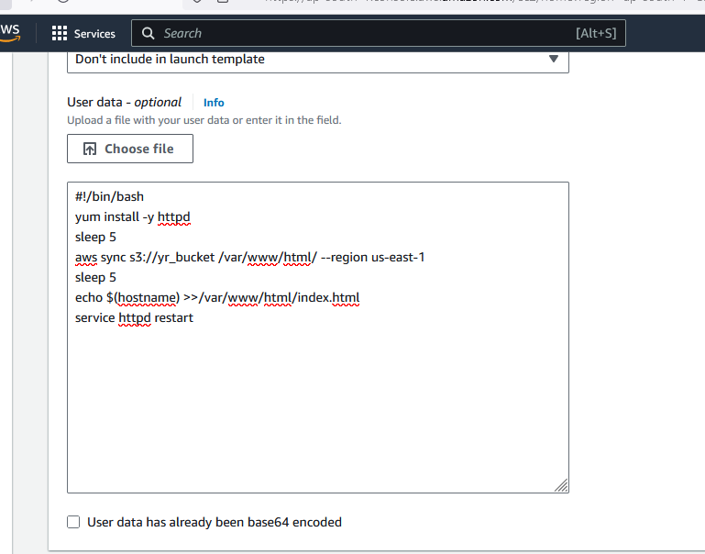

**Observation-**

**while connecting to ec2 instance launched with this template in web page I am able to see vm hostname and the content which I have written in folder.**

#!/bin/bash -------- use bash shell

yum install -y httpd ----------- httpd install

sleep 5 ------------------- delay of 5 sec will create

aws sync s3://yr_bucket /var/www/html/ --region us-east-1 ----------- back up of ec2 instance in s3 ,when we do any changes in ec2 instances or changes made in web server it will save in s3 and sync. Stores all the information about website (lot of pages , back end data base links ). Here bucket name must be unique.

sleep 5

echo $(hostname) >>/var/www/html/index.html -------- hostname will print in web page to check which instance is running and append in index.html

service httpd restart ---------- every time modifications done in server will save

error – yr_bucket

Bucket names can consist only of lowercase letters, numbers, dots (.), and hyphens (-).

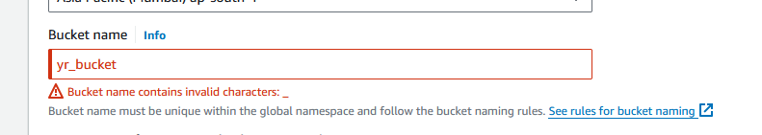

We have to change bucket name as bucket names must be unique and it directly associated with url of bucket and it must be unique.

So changing bucket name –

New name of bucket and recreating template with that

yr-bucket1234

created template with new bucket name and give UDS >> launch instance >> created bucket region with name yr-bucket123. 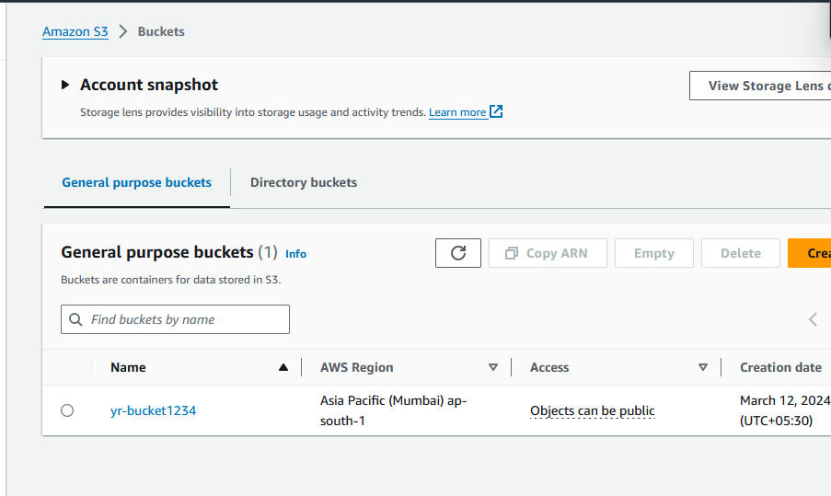

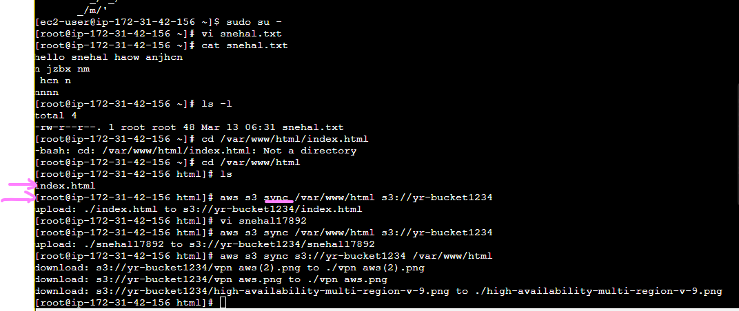

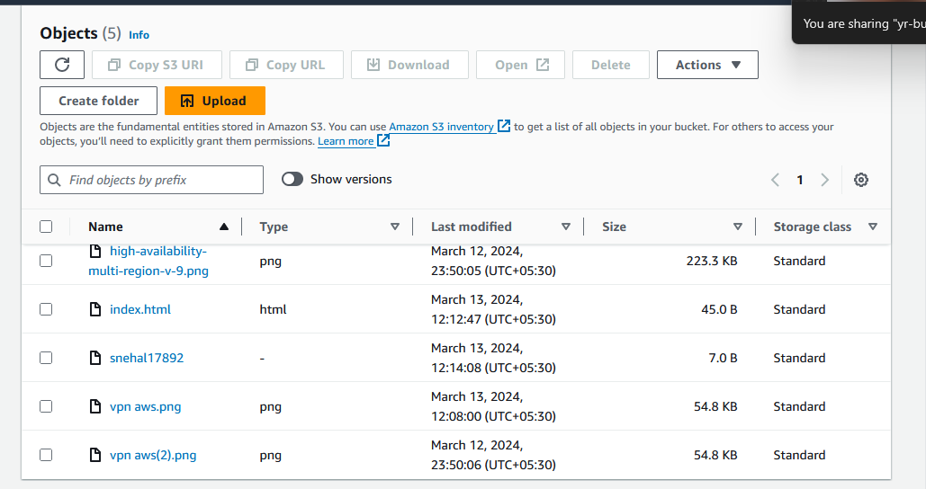

Website hostname is visible according to UDS

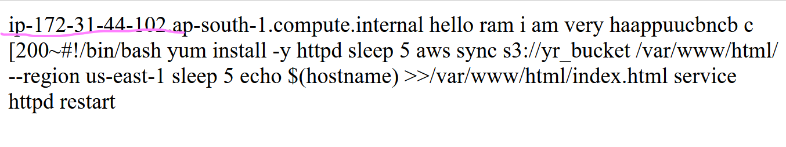

**TASK No:-5**

**Create Auto Scaling**

**Step 1 Create Launch Template**

**1)Create Launch**

**Template..mylaunch1**

**Ec2 >> templates >> launch templates >> select amazon ami in quick start >> tier2.micro instance type >> security group >> in advance option enter the user data script**

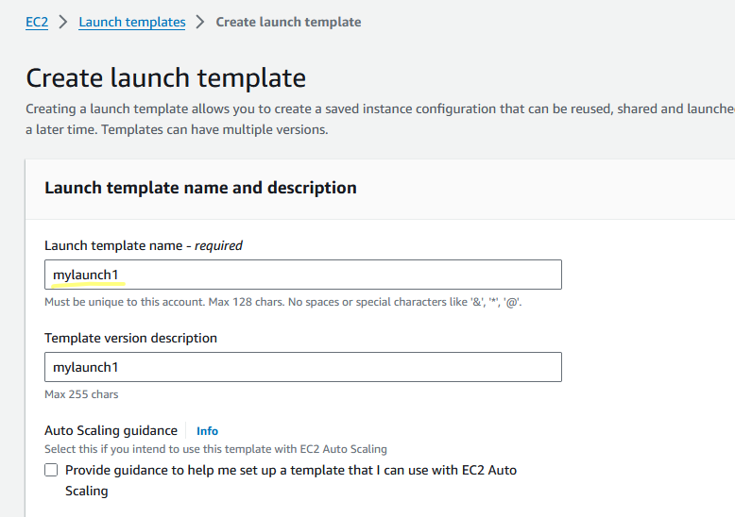

**Amazon Ami -**

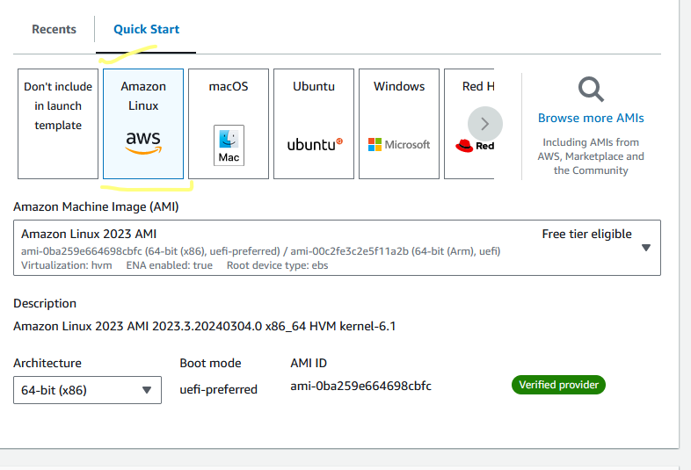

**t2micro-**

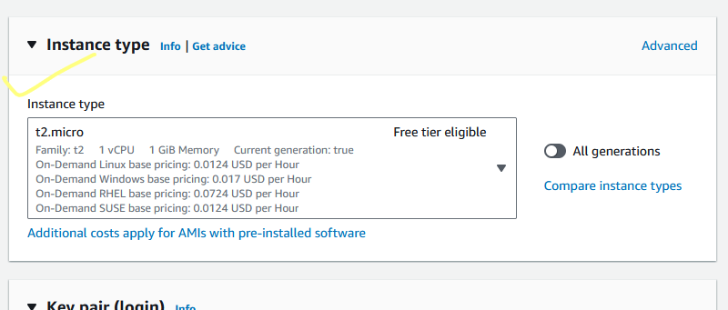

**Select Security group**

**MySg_web_ssh**

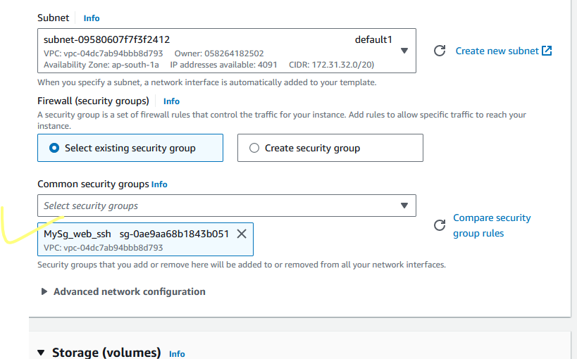

**4)Select Role created in Task 2**

We have option in advance setting to select role while creating templates

Advance option >> select ec2role

**Ec2role is having s3fullaccess and cloudwatchfullaccess**

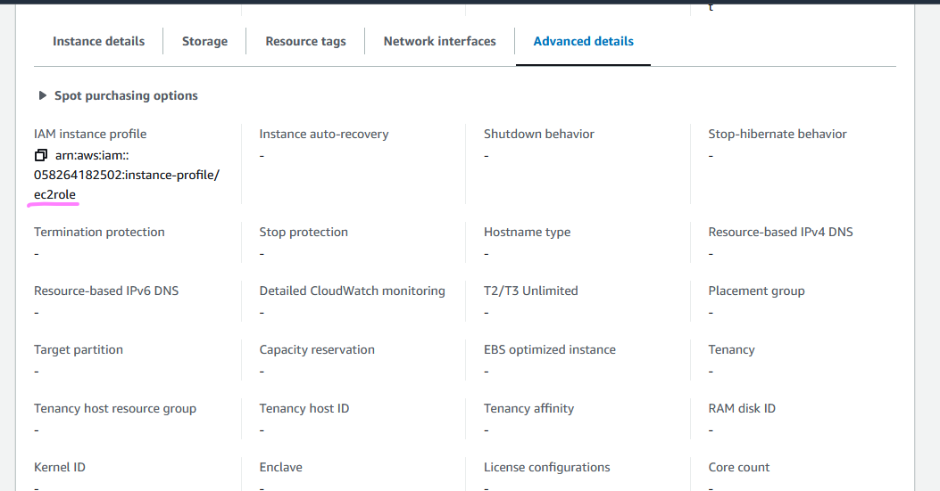



**5)Advance Detail select user**

**data script created in Task 4**



**Template created –**

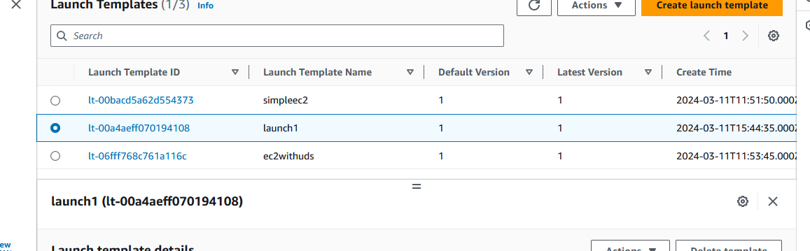

**Observation –**

While creating templates for instances we can add AMI , SG, role , user data script for provisioning of ec2 , storage can modify , type of instances we can select and we can also create versions of templates also.

**TASK No:-6**

**1)Create Auto Scaling group**

**2)Start with 2 instance**

**3)Network Select your VPC**

**4)Make sure all 3 subnets are chosen**

**Solution -**

**Create template –**

Ec2 >> asg >> create asg >> selected **3 subnets** >> and enabled target tracking for 50% cpu utilization >> added sns topic

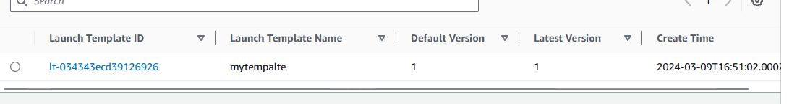

Selected all subnets

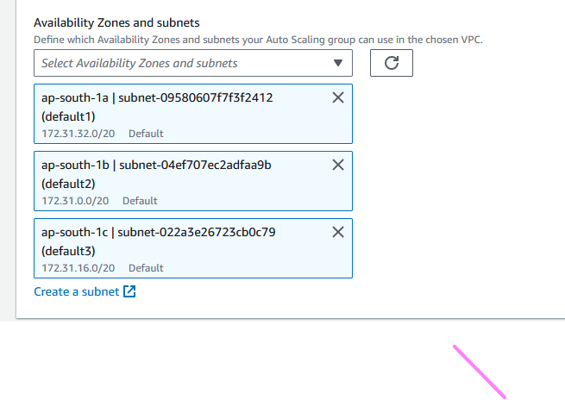

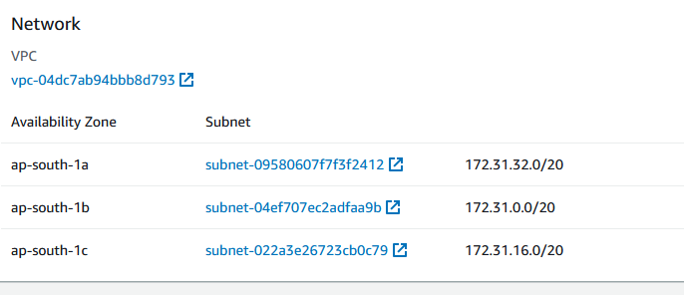

ASG created- ec2>> ASG >> use mytemplate

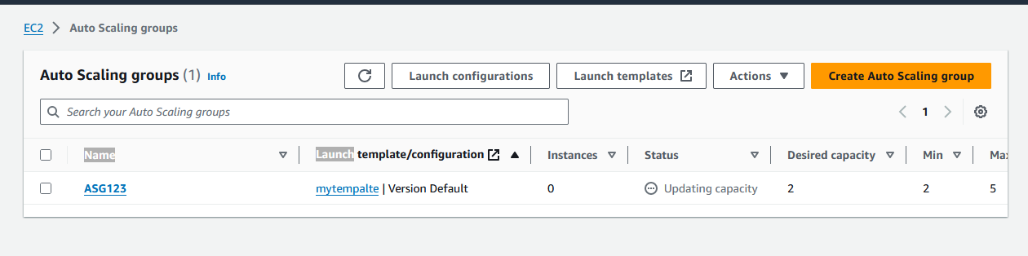

2 ec2 created initially in vpc and in running state –

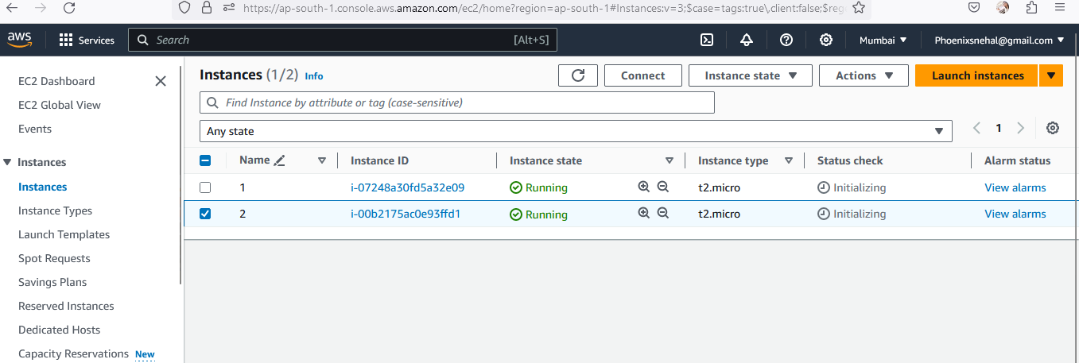

And target triggered alarm created for 2 instances -

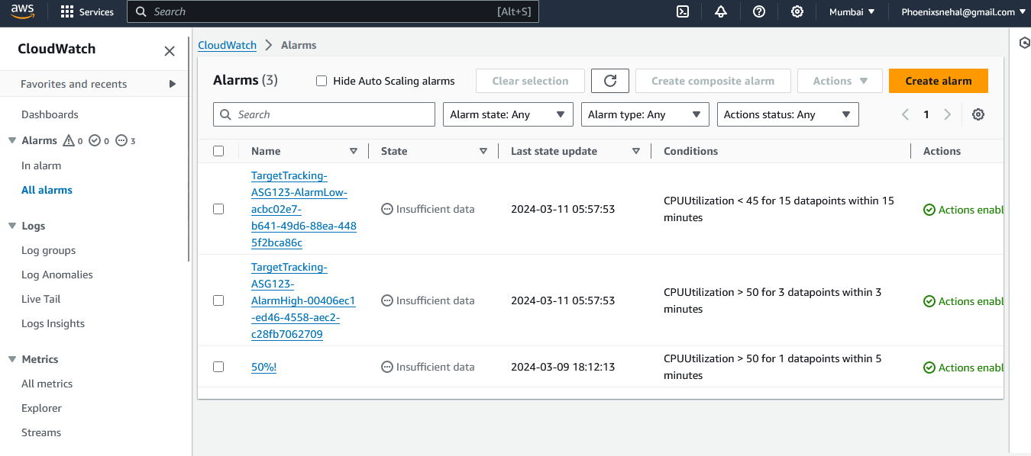

Received email when instances started creating –

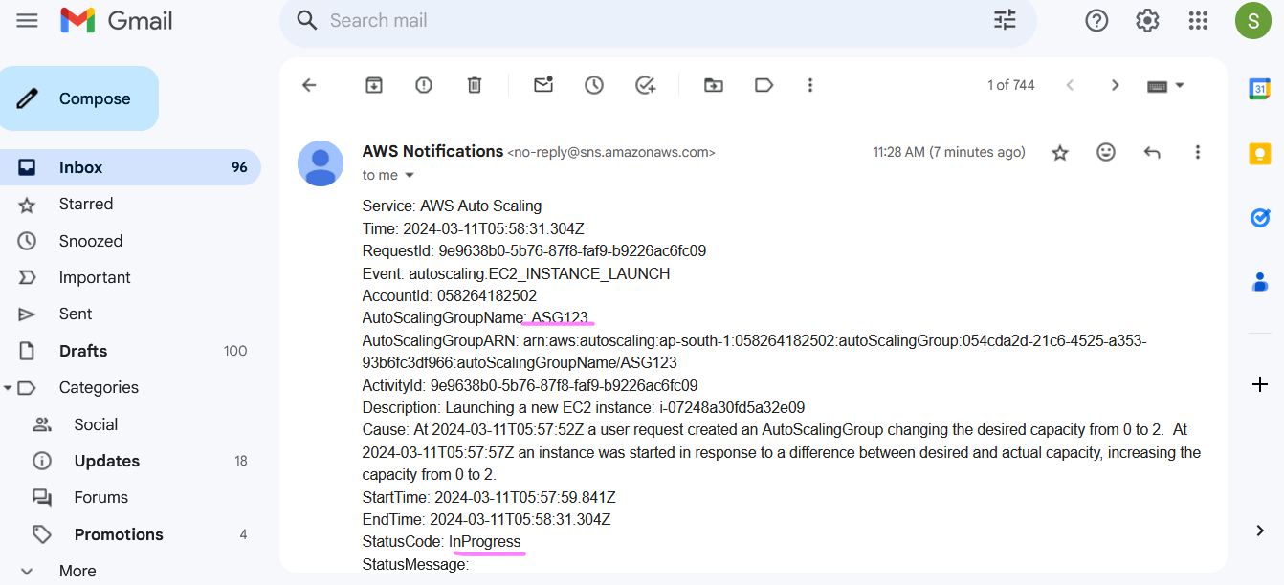

Load increased then 50 % on instance 1 and 2 – getting more then two instances after load exceeds 50 %

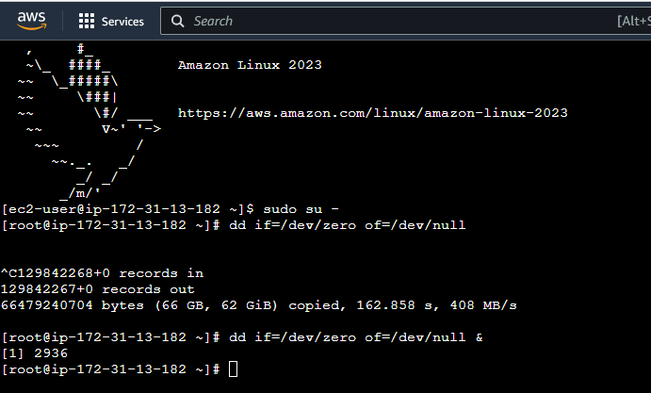

Because I have selected subnet c aws send mail for instance failed

Pls refer the email-

Description: Launching a new EC2 instance.  Status Reason: Your requested instance type (t2.micro) is not supported in your requested Availability Zone (ap-south-1c). Please retry your request by not specifying an Availability Zone or choosing ap-south-1a, ap-south-1b. Launching EC2 instance failed.

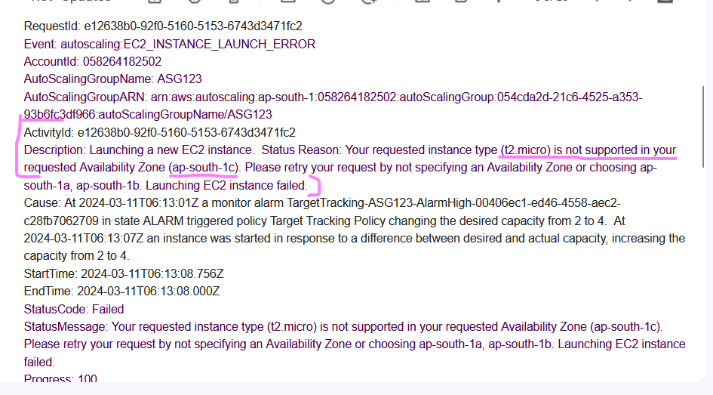

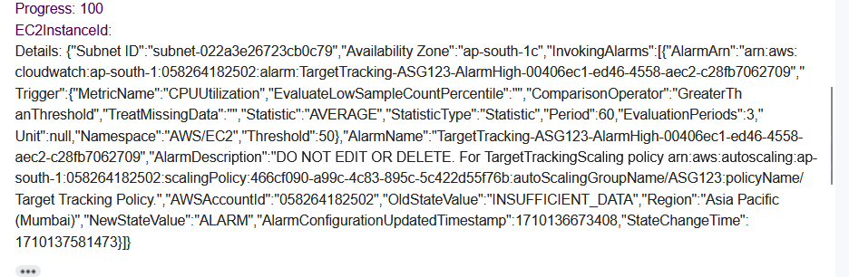

Note – All instances was created in ap-south-1a and ap-south-1b

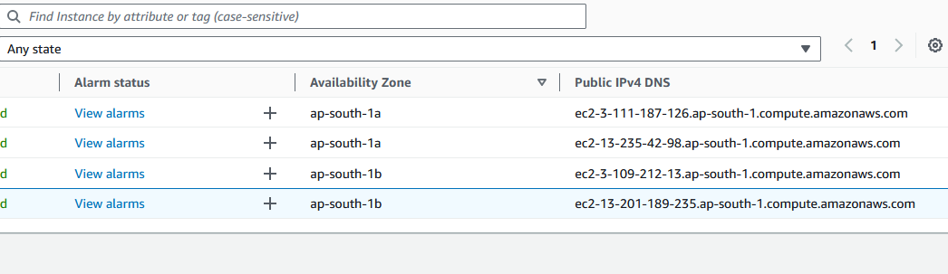

One more instance created ap-south-1b zone and in the process of health check-

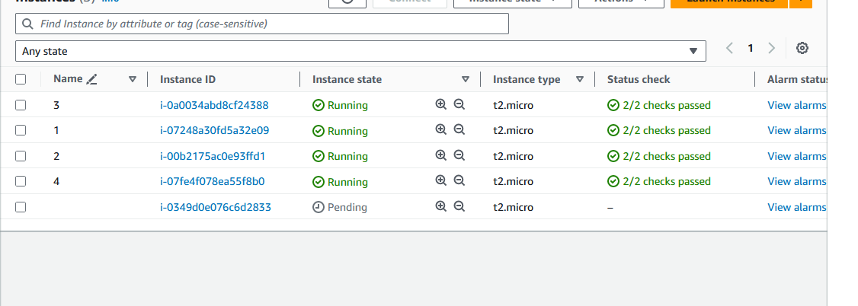

In the below diagram all 5 instances created as max number was provided 5

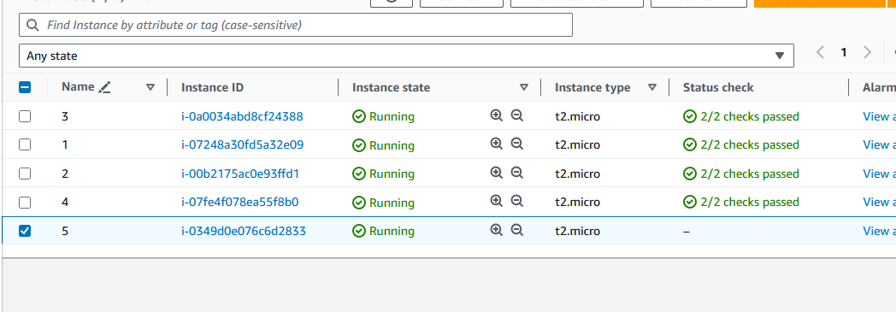

**Observations form this task is**

When we select subnet ap-south-1c for t2.micro instances aws will give you instance launched failed mail with below description and cause-

“**Description**: Launching a new EC2 instance.  Status Reason: Your requested instance type (t2.micro) is not supported in your requested Availability Zone (ap-south-1c). Please retry your request by not specifying an Availability Zone or choosing ap-south-1a, ap-south-1b. Launching EC2 instance failed.  
**Cause**: At 2024-03-11T06:21:22Z instances were launched to balance instances in zones  ap-south-1c with other zones resulting in more than desired number of instances in the group.  At 2024-03-11T06:22:39Z availability zones  ap-south-1c had  0 instances respectively. An instance was launched to aid in balancing the group's zones.”

And all instance will create in ap-south-1a and ap-south-1b subnets only.

**Solution** – we need to select different instance type for subnet ap-south-1c.

**Task 7**

**1)Create an SNS topic…. scalealert**

**2)Minimum 2 and Max 4 instances**

**3)Create scale**

**out (increase) 50% CPU alarm**

**With SNS alert**

**4)Create Scale In also**

**5)After successful creation**

**Check auto scaling group Activity**

Created ASG

**Steps**

# **Ec2>> ASG >> create auto scaling give name(ASG123)>>select launch tamplate >>next >>**Choose instance launch options >>select subnet and vpc >>configure group size and scaling >>min instance (2 ), max (4), desired (2)>>turn on target tracking (target CPU utilization 50%)>>next >>add notification (SNS topic select ***scalealert*** )>>

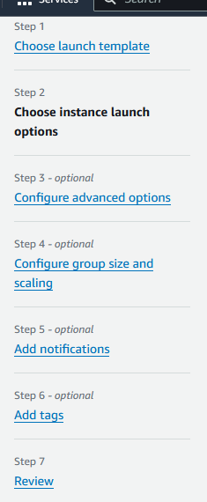

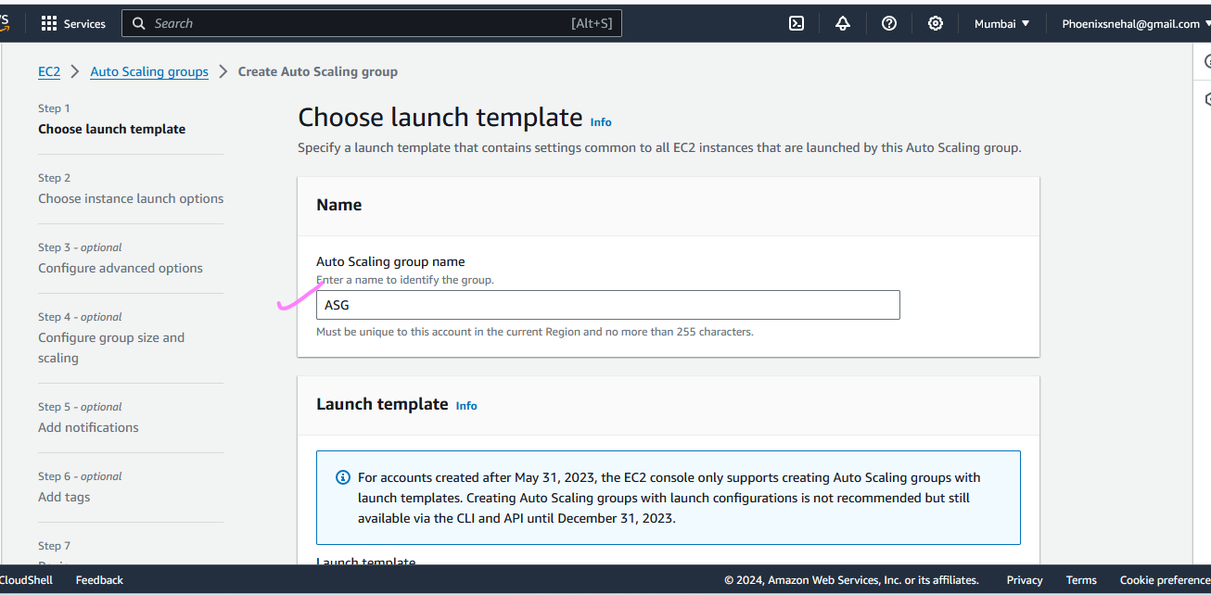

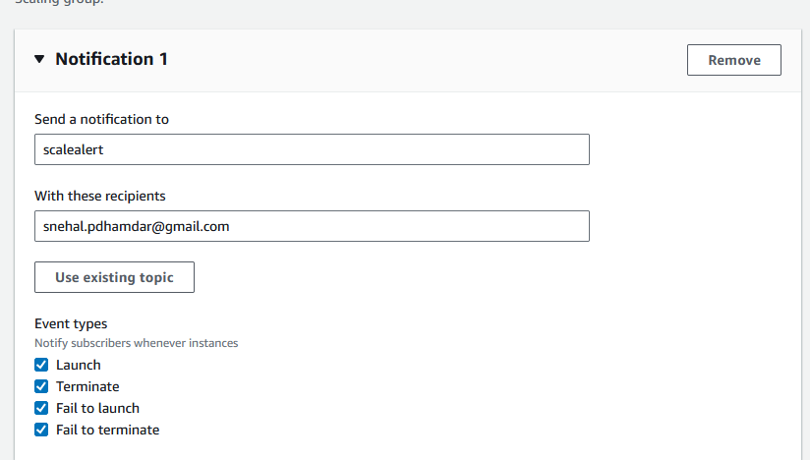

Complete info of ASG123

## Step 1: Choose launch template

### Group details

Auto Scaling group name

ASG123

#### Launch template

Launch template

[simpleec2](https://ap-south-1.console.aws.amazon.com/ec2/home?region=ap-south-1#LaunchTemplateDetails:launchTemplateId=lt-00bacd5a62d554373)

lt-00bacd5a62d554373

Version

Default

Description

simpleec2

## Step 2: Choose instance launch options

### Network

#### Network

VPC

[vpc-04dc7ab94bbb8d793](https://ap-south-1.console.aws.amazon.com/vpc/home?region=ap-south-1#vpcs:sort=VpcId;search=vpc-04dc7ab94bbb8d793)

Availability Zone

Subnet

ap-south-1a

[subnet-09580607f7f3f2412](https://ap-south-1.console.aws.amazon.com/vpc/home?region=ap-south-1#subnets:sort=SubnetId;searchsubnet-09580607f7f3f2412)

172.31.32.0/20

ap-south-1b

[subnet-04ef707ec2adfaa9b](https://ap-south-1.console.aws.amazon.com/vpc/home?region=ap-south-1#subnets:sort=SubnetId;searchsubnet-04ef707ec2adfaa9b)

172.31.0.0/20

### Instance type requirements

This Auto Scaling group will adhere to the launch template.

## Step 3: Configure advanced options

### Load balancing

#### Load balancer

-

### Health checks

Health check type

EC2

Health check grace period

300 seconds

### Additional settings

Monitoring

Disabled

Default instance warmup

Disabled

## Step 4: Configure group size and scaling policies

### Group size

Desired capacity

2

Desired capacity type

Units (number of instances)

### Scaling

Minimum desired capacity

2

Maximum desired capacity

4

Target tracking policy

Policy type

Target tracking scaling

Scaling policy name

Target Tracking Policy

Execute policy when

As required to maintain Average CPU utilization at 50

Take the action

Add or remove capacity units as required

Instances need

300 seconds to warm up before including in metric

Scale in

Enabled

### Instance maintenance policy

Replacement behavior

No policy

Min healthy percentage

-

Max healthy percentage

-

### Instance scale-in protection

Instance scale-in protection

Enable instance protection from scale in

## Step 5: Add notifications

### Notifications

Notification 1

SNS Topic

scalealert (snehal.pdhamdar@gmail.com)

Event types

LaunchTerminateFail to launch

Fail to terminate

## Step 6: Add tags

### Tags (0)

| **Key** | **Value** | **Tag new instances** |
| --- | --- | --- |
| **No tags** | | |

**Subscribe sns topic – scalealert as shown in above diagram**

**Created ASG123**

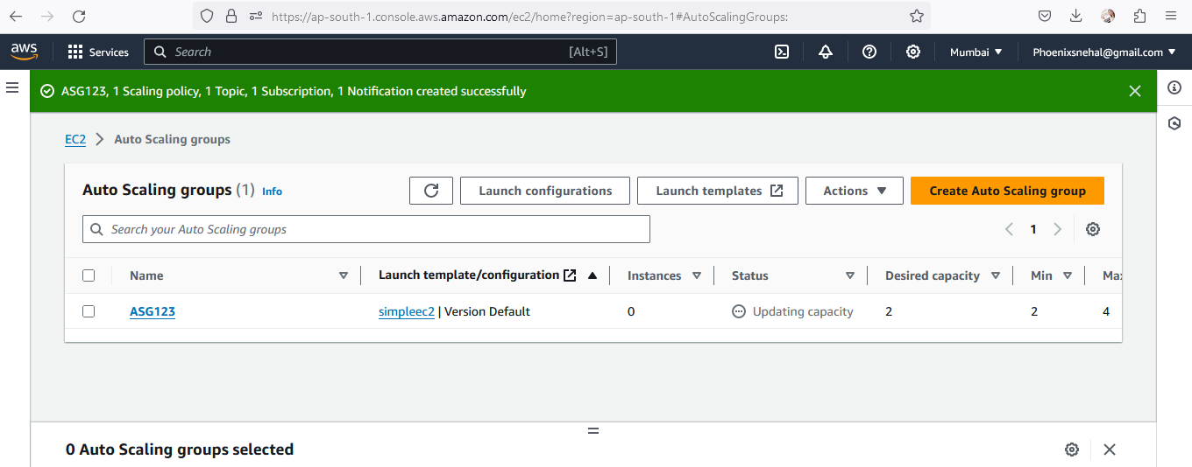

**Created 2 instances**

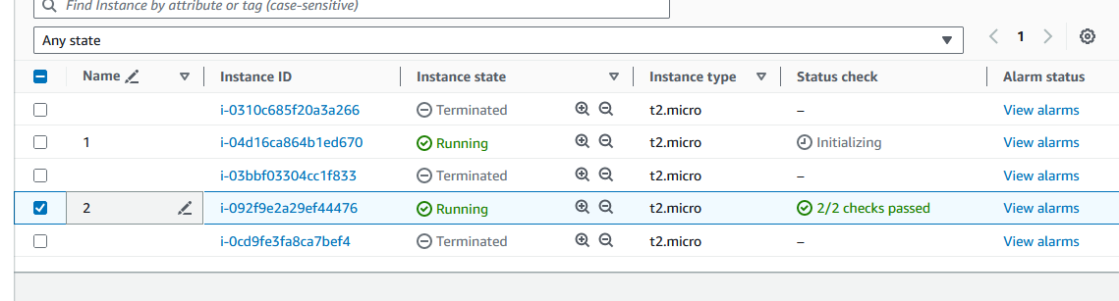

Parallelly two alarms also created

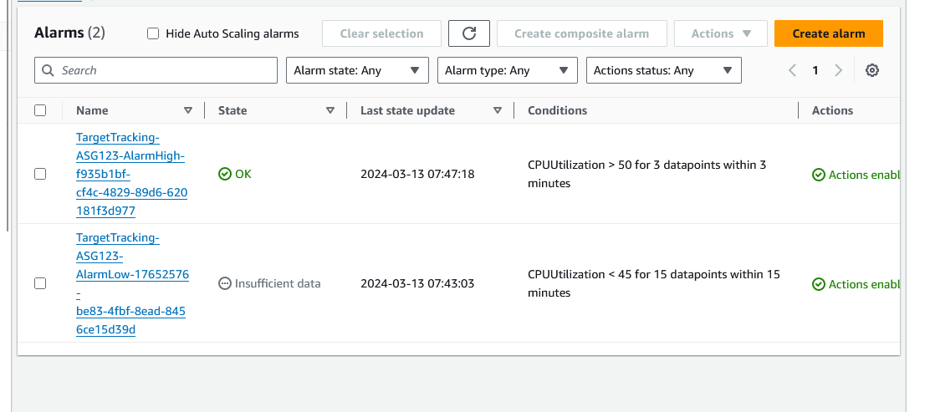

**Increasing load more then 50%**

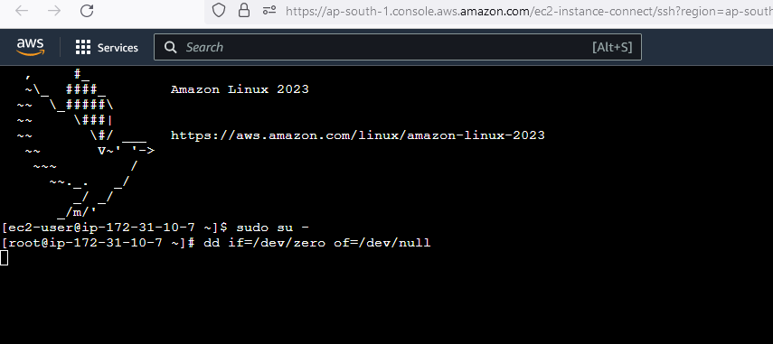

Parallelly SNS notification got on email for creation of ASG123

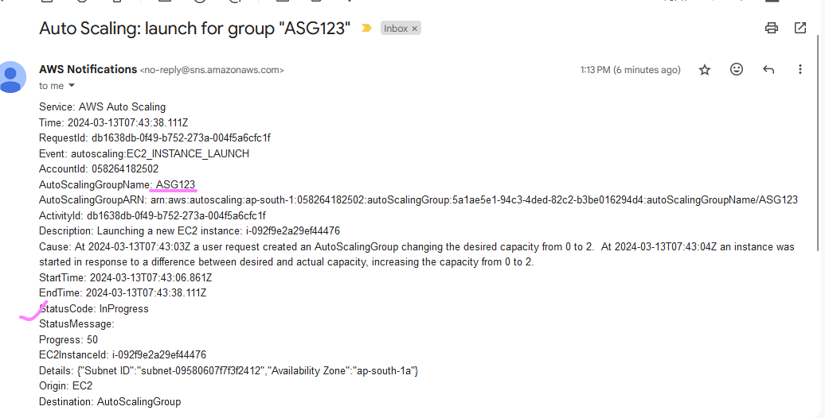

Cpu utilization is increasing

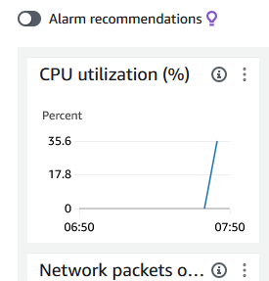

Increasing instance count as load is increasing and reached to 4

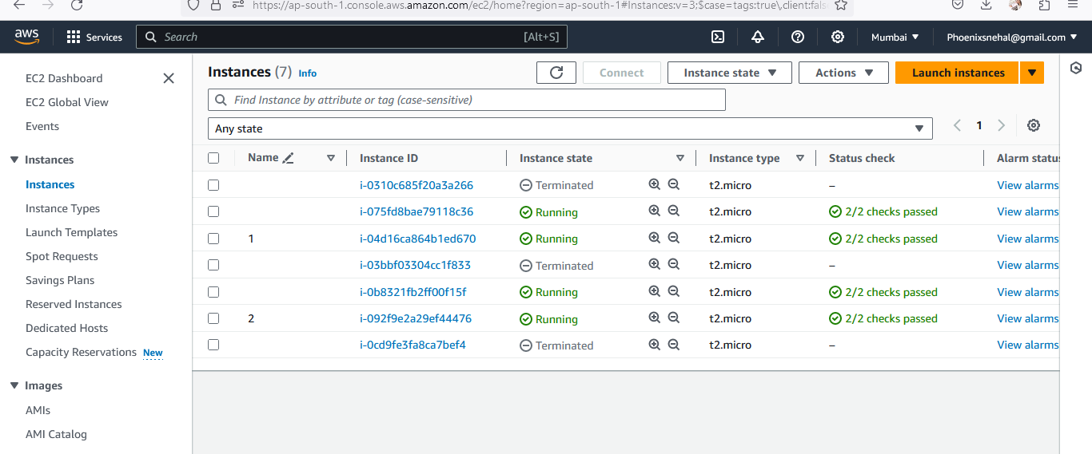

**And got nitification on email-**

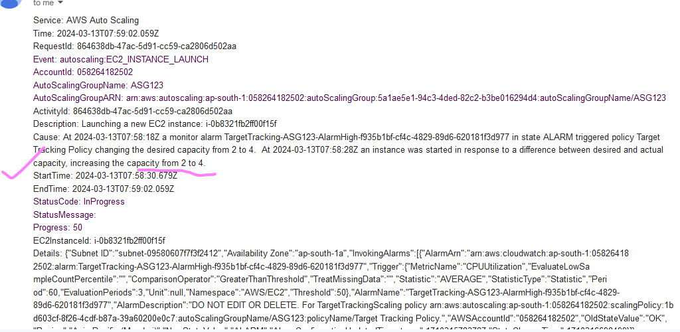

**Now reducing the load –**

It will take some min to turn off the instances only desired instances is up and running.

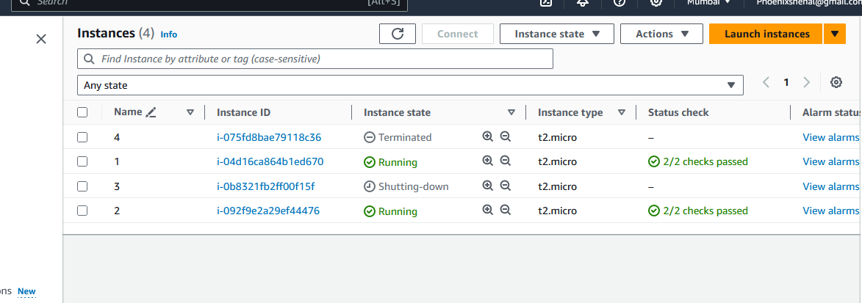

Sns notification for turning off

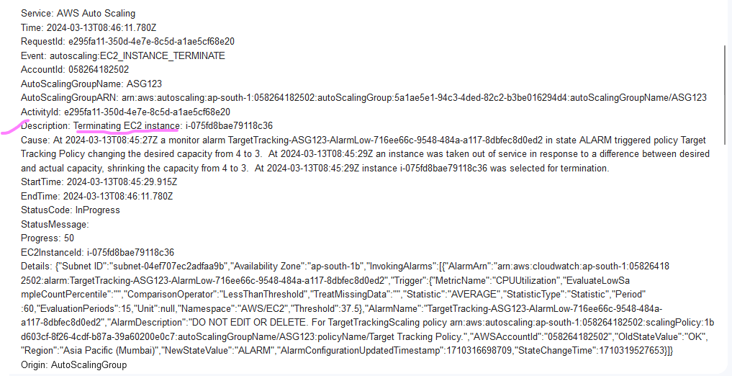

Observation –

ASG is working with sns topic and scaling its instances according to load if load increasing the number of instances increase and if load decreasing asg will reduce the count of instances and at the same time we will get notification in emails if we enable the sns topic.

**TASK**

**No:9**

**Create Load Balancer and add auto scaling**

**1)Create Classic Load Balancer**

**2)Make it Public**

**3)Select yr VPC**

**4)Select all subnets**

**5)Select MySg_web_ssh security**

**group**

**6)*****Do not Select Instances\*\***

**7)Add ELB to Auto Scaling group**

**Create sg for load balancer**

**Create classic load balancer**

2 desired instances running as load is below 50%

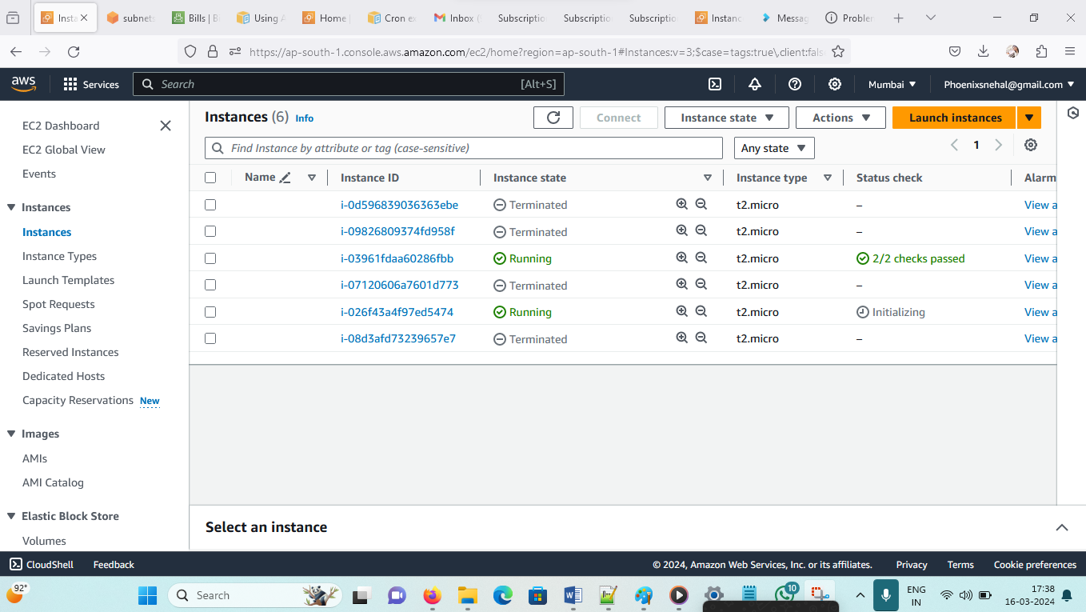

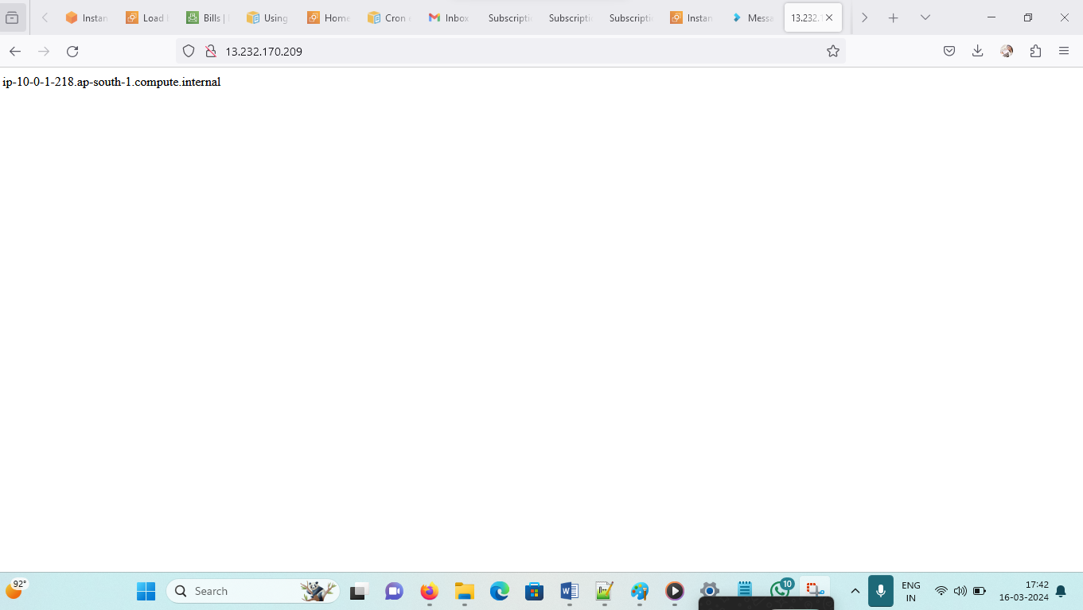

LBfortask9-1291078360.ap-south-1.elb.amazonaws.com

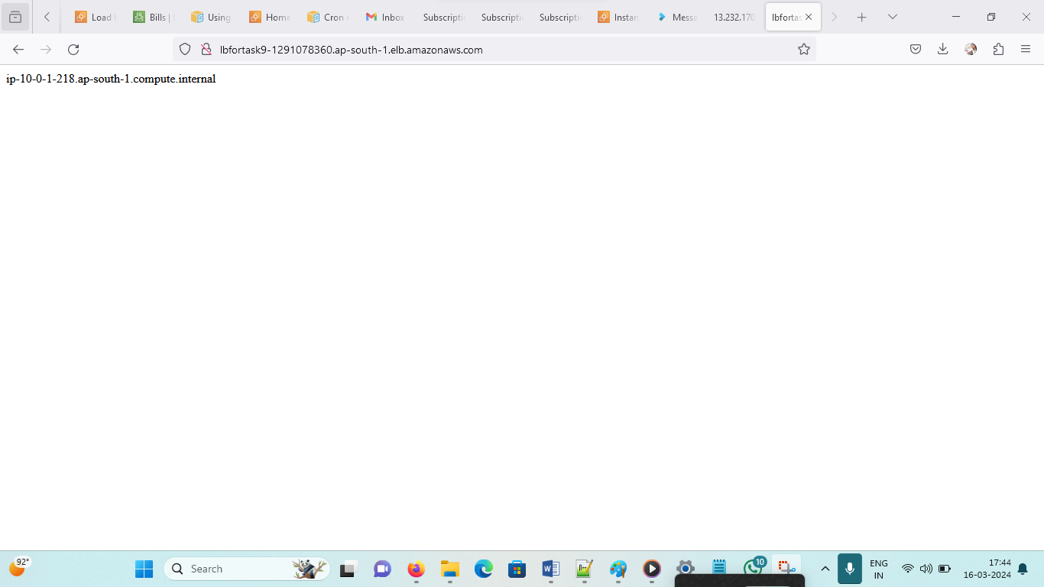

**Increase 50%**

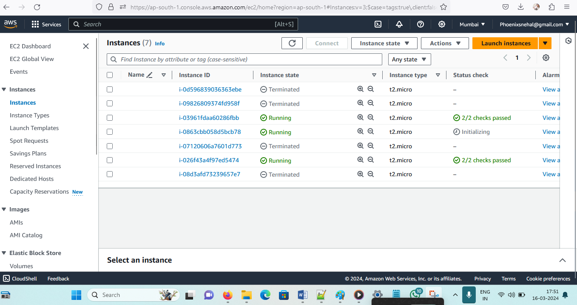

**4 instances created -**

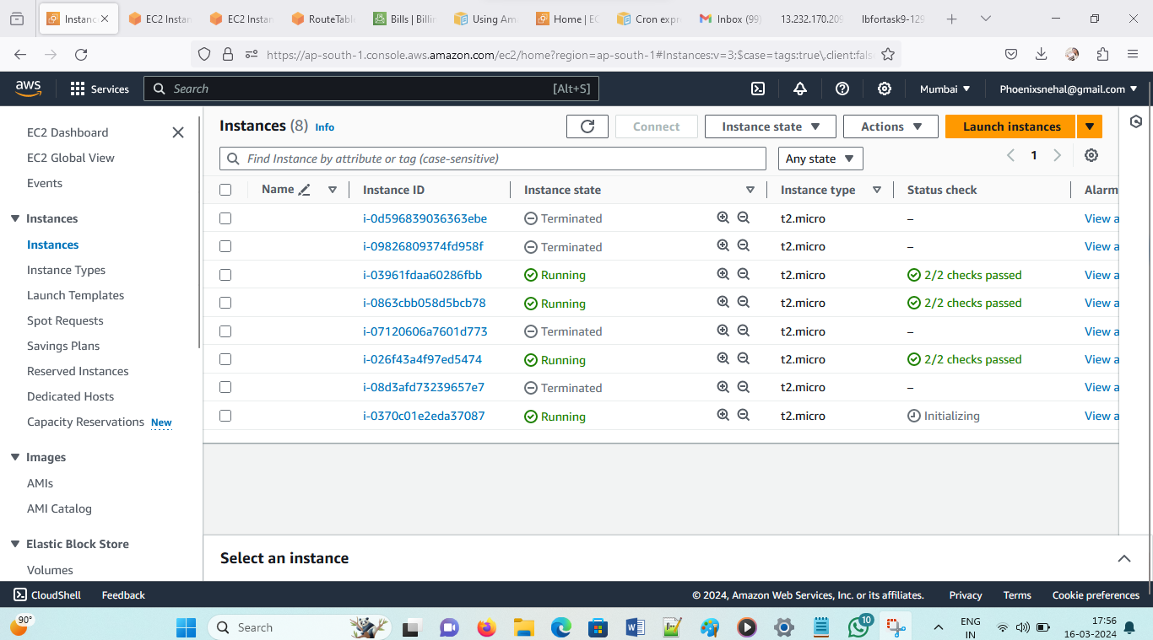

**Sns notification**

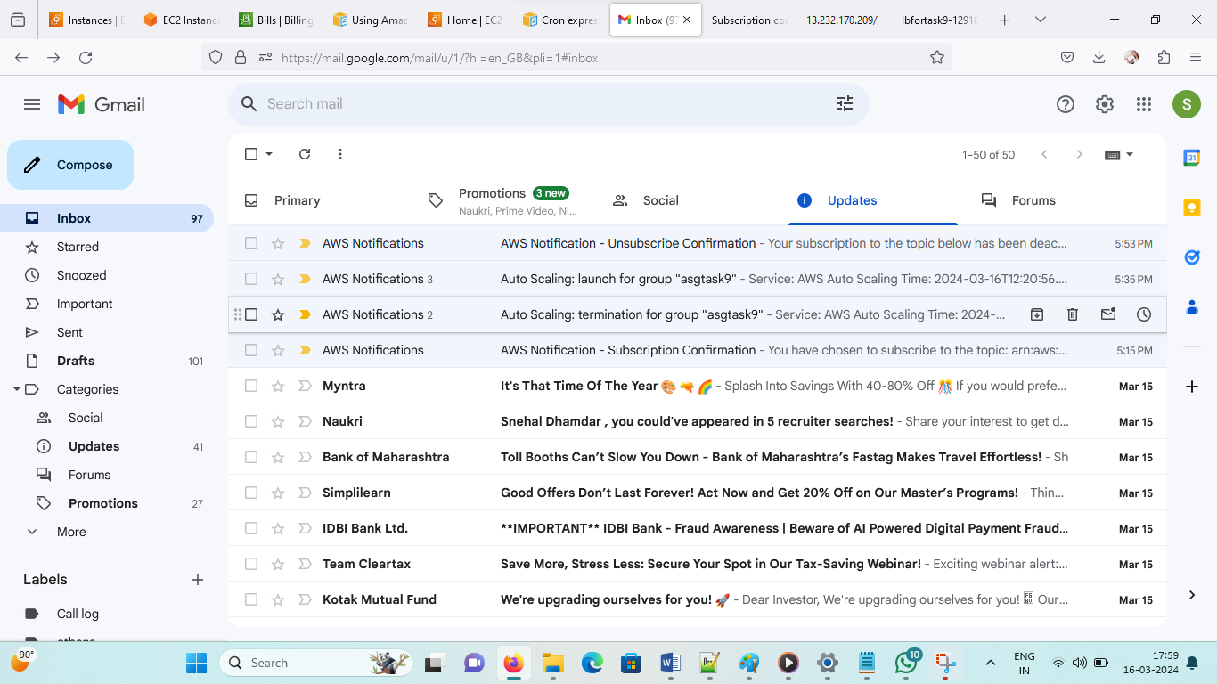

**Load balancer changes instance**

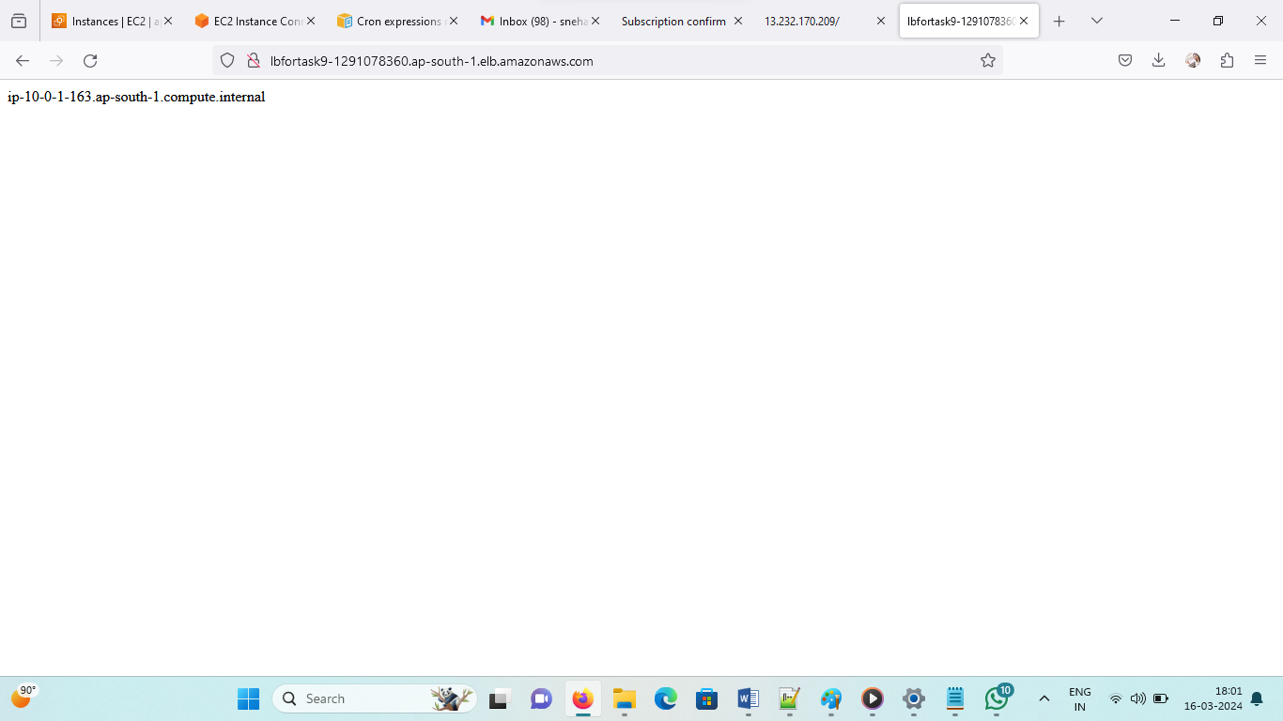

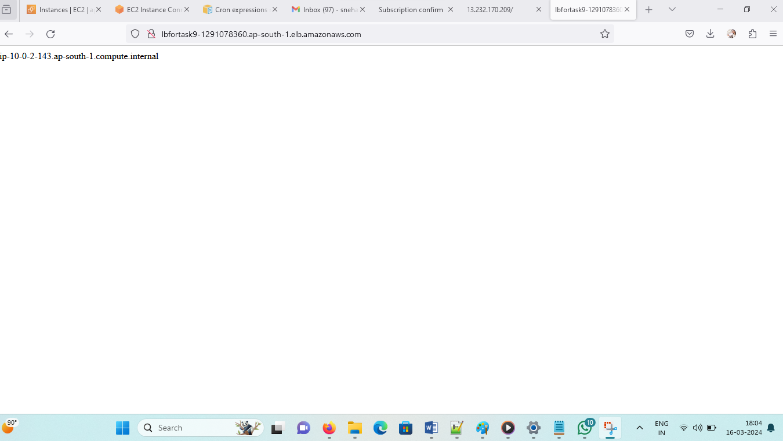

**Reached load to max count of instances goes into max (5)**

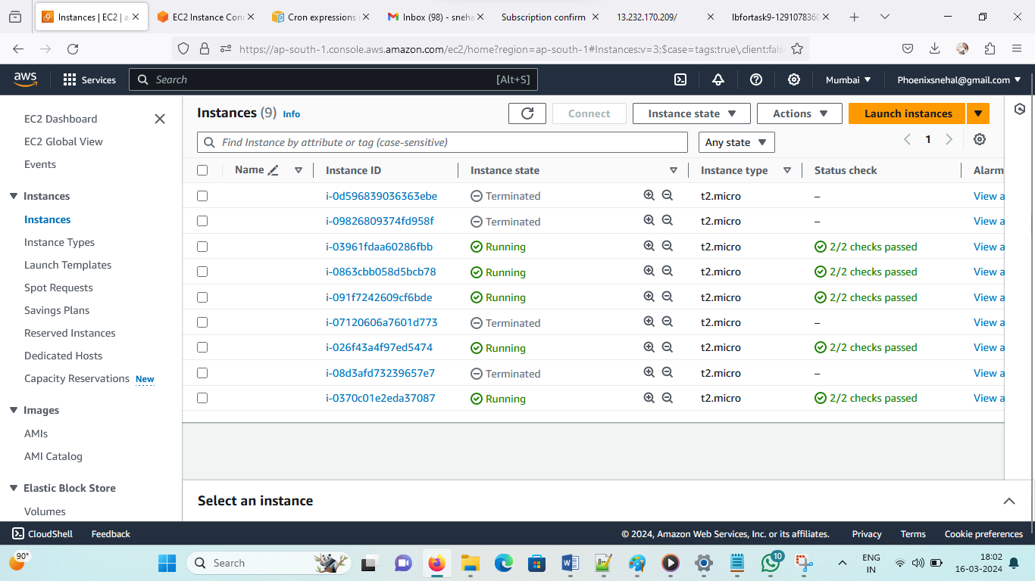

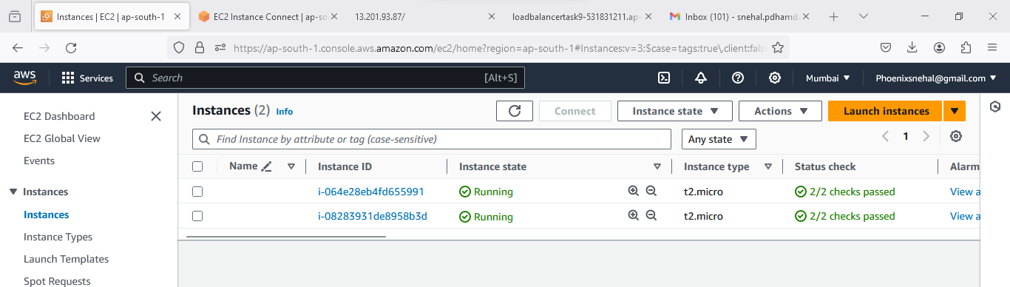

**TASK No:- 10**  
Create Route 53  
1)Create Domain Registration  
Go Daddy  
2)Create Public hosted zone  
in route 53  
3)Create a CNAME record  
Pointing to ELB URL  
domain name ---> A record ---> IP address  
domain name --- > CNAME record -------> ELB URL

**Final Testing steps for project**

**1)Test your domain URL should get page from 2 Different IP ( servers)**

**2)Now terminate 1 instance and check URL only coming from 1 IP (ec2 instance)**

**3)After 5 min check if auto scaling has launched a new instance**

**4)Again Test your domain URL, it should get output from 2 Different IPs (ec2 instances)**

**5) Increase CPU utilization on one instance and then check if 3rd instance has been launched by ASG**

**1.**

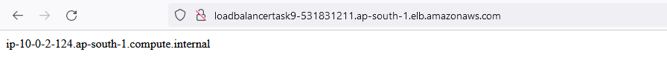

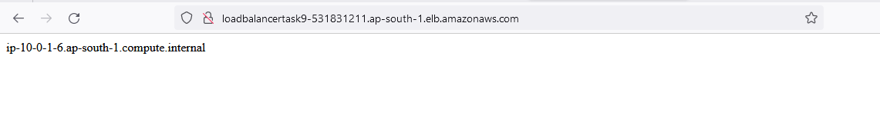

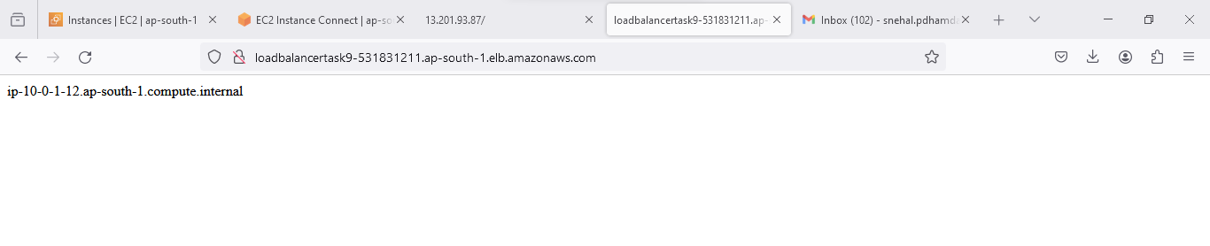

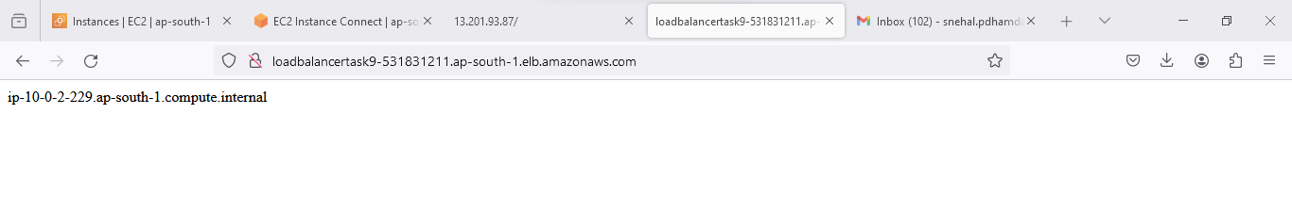

Increasing instance count as load is increasing and reached to 4